**Bramley Class Weekly Overview**

**Week Commencing 23rd September 2024**

**English**

We are continuing our text for this term, Traction Man. We will be 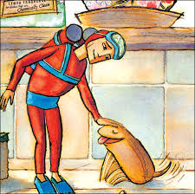using role play to better understand different aspects of characters. We will also be starting to use speech marks and learning about writing direct speech as part of a narrative.

Phonics (Year 1) – We will be reviewing all graphemes taught this year.

Phonics/spellings (Year 2) – continue to work on the different digraphs for the ‘ee’ sound.

Handwriting –

Year 2 will be starting to work on our joins between letters from the different letter families, using patterns to help us.

Year 1 will be building on their letter orientation and formation, looking at the different letter families.

**Maths**

***Year 1***

This week we are continuing work on counting 1 more, 1 less and counting backwards.

In this unit we will look at:

* Sorting objects
* Counting objects
* Representing objects
* Recognising numbers as words
* Counting on from any number
* 1 more / 1 less
* Less than/greater than/equal to
* Using a number line

**Key Vocabulary**

One more, one less, tens, ones, after, before.

***Year 2***

This week we will be looking at how we order numbers and objects, comparing and estimating, and counting in 2s, 5s and 10s.

In this unit we will:

* Use numbers to 20
* Count objects to 100 by making tens
* Recognise tens and ones
* Use a place value chart
* Partition numbers to 100
* Write numbers to 100 in words
* Count in 10s and 1s on a number line

**Key Vocabulary**

Count in steps, count in multiples, place value, estimate, compare

**Science**

In Science this week we will be carrying out investigations into the five senses.

**Topic**

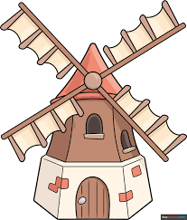This week, in history we will compare Victorian and modern houses inside, finding differences in what bathrooms and bedrooms looked like in the past and what they look like now.

In DT, we will be making stable and strong bases for windmills. We will experiment with different shapes and materials.

**RE**

This week, we will be learning about what parables are. We will use drama to explore the parable of The Prodigal Son from the New Testament and discuss what Christians can learn about God from Jesus who told these parables.

**PE**

During our PE lesson this week, we will be continuing with our work on the Fundamentals of P.E, following different instructions and noticing the way our bodies change when we exercise. We will also be building on our team works skills.

**Forest School**

For Forest School this week, we are looking at Andy Goldsworthy and creating some wonderful leaf art.