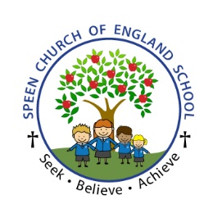
SEEK, BELIEVE & ACHIEVE IN DESIGN AND TECHNOLOGY

Intent
Design and Technology at Speen, aims to inspire children through a broad range of practical experiences to create designs which solve real and relevant problems within a variety of different contexts. Pupils are encouraged to become independent, creative problem-solvers and thinkers as individuals and as part of a team. The iterative design process (design, make, evaluate) is fundamental and runs throughout the teaching in all year groups. This process encourages children to identify real and relevant problems, evaluate existing products and then take risks and innovate when designing and creating solutions using skills from across the curriculum; maths, science computing and art. As part of the process time is built in to discuss, evaluate and improve on prototypes using specific design criteria.

Implementation
Design Technology is to be taught in all year groups through a termly topic. Design Technology projects are often made cross curricular where possible - linking to other subjects taught in the curriculum, often science, mathematics and topic. Our design technology lessons give pupils the skills and knowledge that enable them to think creatively and imaginatively to design, make and evaluate products. Planning and teaching allows for the revision of ideas to become part of good practice and ultimately helps to build a depth to children understanding. Through revisiting and consolidating skills, children build on prior knowledge alongside introducing new skills, deepening their critical thinking and encouraging a greater level of challenge. The revision and introduction of key vocabulary is built into each unit of work. Food technology is implemented across the curriculum with children developing an understanding of where food comes from, the importance of a varied and healthy diet and how to prepare this. Through carefully planned, well-resourced and delivered lessons, we intend to inspire pupils to develop a love of Design and Technology and see how it has helped shaped the ever-evolving technological world they live in.

Impact

Our carefully designed, well-resourced and high-quality curriculum, will ensure that design technology is valued and taught consistently across the school, with technical vocabulary displayed, spoken and used by all learners. Teachers will develop strong subject knowledge, feel confident in their teaching and will have a clear understanding of the progression of skills across the key stages. We want to ensure that Design and Technology is loved by all pupils, therefore encouraging them to want to continue building on their wealth of skills and understanding, now and in the future. Impact can also be measured through key questioning skills built into lessons, child-led assessment such as success criteria.

